Connor Leu, Abdon Morales, Lauren Parker (lnp735)

Lab 0 - Measuring Distance and Time

# Part 1: Geometry and Precision Measurement

**Method**

We want to determine whether or not a marble is a real sphere. The marbles appear to be spherical, but we aim to quantitatively determine this. We can accomplish this by measuring the diameter of the same marble across multiple positions on the marble. We can say the marble is a sphere if all measured diameters are equal to each other. We predict that the marbles will be considered spherical.

For Part 1, we are performing measurements with two different tools: a standard tape measure and a caliper with precision of 0.02mm. We chose the caliper due to the nature of the lab as we aren’t needing to measure something with as much precision as a micrometer provides, and the tape measure is one of the required tools.

To collect our measurements we orient the marble(s) in three different orientations, measuring their diameter each time, denoting each diameter as D1/D2/D3 respectively. Our analysis tools will include basic calculator tools and spreadsheet software, if needed, for computing statistical data. The marbles we are measuring are constant throughout the experiment, however as the point of Part 1 is to measure their diameters, those values will change. It is highly likely that the random uncertainty is larger than the systematic uncertainty as shown

In comparison to another group, we had a very similar approach to the experi

**Data**

The below table highlights our diameter measurements for each marble (D1 / D2 / D3) using the **caliper**. Our uncertainty is likely to be 0.01mm as we are measuring an analogue device, and its smallest precision is 0.02mm.

**Marble Measurements with the Caliper (D1 | D2 | D3)**

| Yellow Marble | 13.34 +/- 0.01mm | 14.32 +/- 0.01mm | 14.20 +/- 0.01mm |
| --- | --- | --- | --- |
| Green Marble | 14.80 +/- 0.01mm | 14.94 +/- 0.01 mm | 14.88 +/- 0.01mm |
| Red Marble | 13.56 +/- 0.01mm | 13.66 +/- 0.01mm | 13.58 +/- 0.01mm |

The below table highlights our diameter measurements for each marble (D1 / D2 / D3) using the **tape measure**. Our uncertainty is estimated at half a millimeter as the tape measure is only precise to within the millimeter; since this is also an analog measurement, we divide the smallest unit by two for our uncertainty of 0.5mm.

**Marble Measurements with Tape Measure (D1 | D2 | D3)**

| Yellow Marble | 13mm +/- 0.5mm | 12mm +/- 0.5mm | 13mm +/- 0.5mm |
| --- | --- | --- | --- |
| Green Marble | 13mm +/- 0.5mm | 14mm +/- 0.5mm | 13mm +/- 0.5mm |
| Red Marble | 13mm +/- 0.5mm | 13mm +/-0.5mm | 12mm +/-0.5mm |

**Conclusion**

Our data did not support our prediction that marbles are spheres. As shown in the tables above, none of the marbles had a measurement of D1 that was equal to D2 and thus equal to D3. For Part 1, we can see from the above data that measurements with the tape measure were significantly less precise than the caliper. For example, according to the tape measure, each marble’s diameter was measured at whole millimeters with an uncertainty of half a millimeter, but the caliper reported much more precise diameters.

There are several factors that reduce the possible accuracy of the tape measurements. For starters, there are 3 different people taking the measurements; the tape measure has no way to hold the marbles in place while performing the measurements; and the tape measure is only accurate to 1 millimeter.

For future iterations, we would opt to do more than 3 measurements per marble and stay consistent with the person taking the measurements. It would also help to use a more accurate device than a tape measure, such as the micrometer.

We don’t think it is wrong to call the marbles spheres - for all intents and purposes, they are spherical, even if their measured diameters vary from each other slightly. This is numerically different from the definition of a sphere, but these tiny variances (+/- 0.01mm, per the caliper readings) are small enough that for our usage of these marbles they are spherical.

# Part 2

**Method**

For Part 2, we want to determine whether or not the color (or even marble itself) determines the time taken to roll down an inclined slope. We are using a wooden ramp provided in the lab room as well as a digital stopwatch to measure the time taken to descend the ramp, as well as a meterstick to stop the marble from falling off the table. As we have seen from Part 1, the different marbles do have different diameters (such as our red marble being notably smaller than the other two). We predict that color won’t have any effect, but that the geometry of the marble itself impacts rolling time.

We used Google Sheets to track spreadsheet data for the rolling times of each marble.

The marbles we are using are constant (see Part 1) - their diameters, however, do vary slightly. The angle of the ramp will remain fixed throughout the experiment. We are specifically measuring the time taken to roll down the ramp, per marble, across numerous iterations.

**Data**

We have measured the track length as 122.1cm +/- 0.5mm, per our uncertainty on the tape measure from Part 1. Below is a spreadsheet of each marble’s times to roll down the slope over 10 iterations. We released each marble from the top of the ramp at time t=0s and timed how long it took to hit the bottom using a digital stopwatch with a precision of 0.01s.

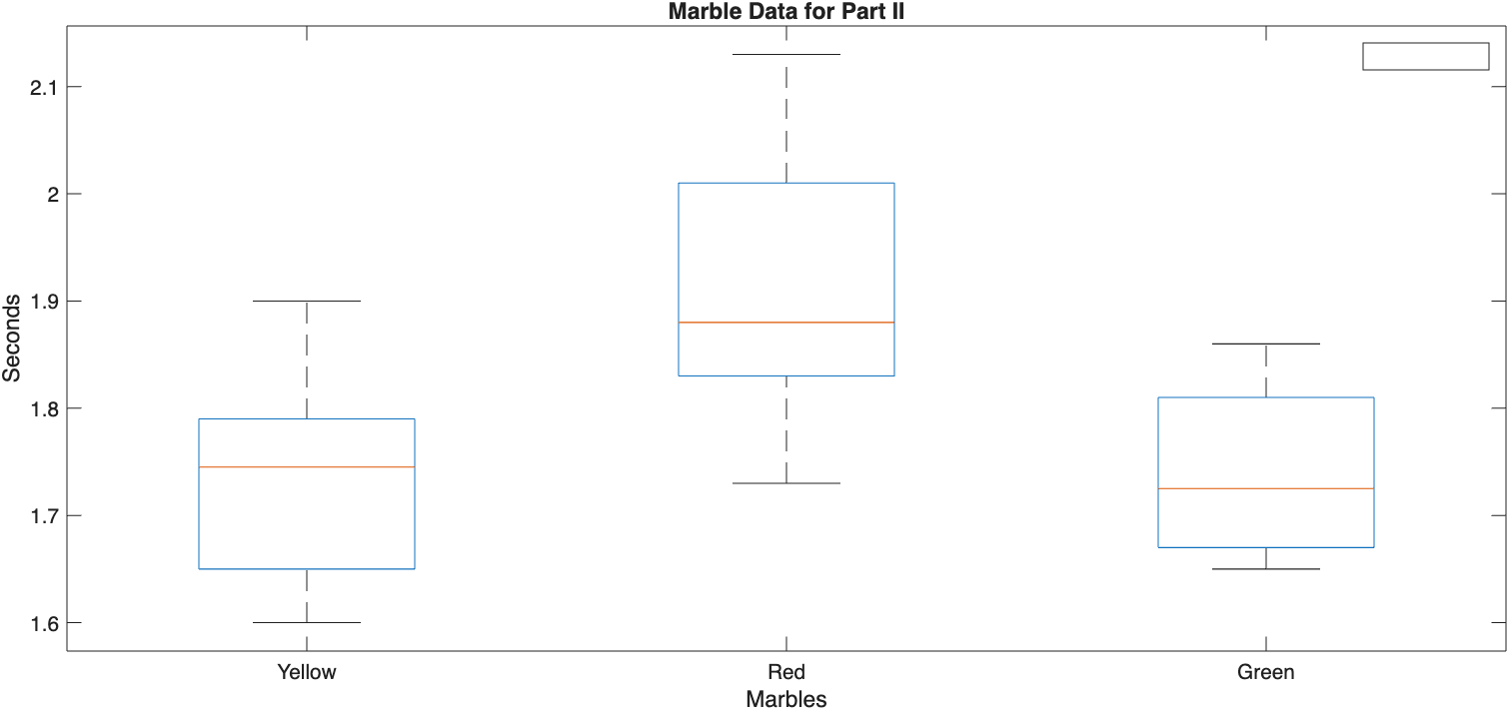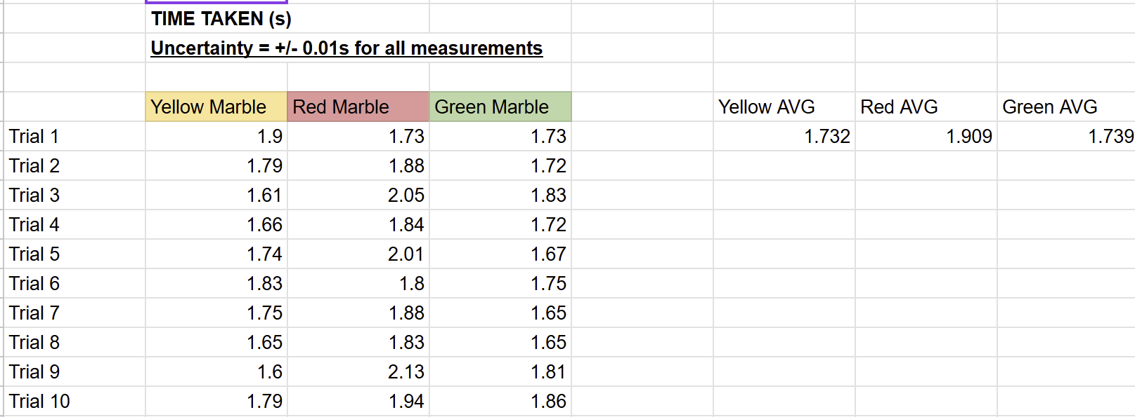

We think the following factors influence the time taken to roll:

1. Human error with the timing
2. The roughness of the ramp
3. Inconsistency between group members on rolling and timing

Google Sheets computed the standard deviation for each marble (yellow, red, green) to be the following times respectively:

1. 0.09953223933 seconds
2. 0.1231485102 seconds
3. 0.07415449338 seconds

**Conclusion**

From our data collected in Part 2, we cannot actually conclude that the color of the marble does not impact rolling time. Per our data, the red marble took almost 0.2 seconds longer to hit the bottom of the ramp than the other two colored marbles (1.91s compared to 1.73s, +/- 0.01s overall error).

In this experiment, we have both systematic AND random uncertainty. Our systematic uncertainty comes from the people involved in the measurements of the experiment. The random uncertainty comes from things we cannot control, such as the ramp surface. A random uncertainty *could* also be from the weights of the marbles, which we never measured, and are unknown quantities that may or may not have impacted the rolling times.

Compared to our prediction, we were incorrect. It is likely that our measurements for the red marble were influenced more severely by the listed factors in the above section. However, looking at the Part 1 data, the red marble had (on average) the smallest diameter compared to the other two marbles. Given that the yellow and green marble roll times were so close to each other, we *also* cannot conclude that the diameter of the marble impacts rolling times either.

For future iterations of the experiment, we would change several things:

1. The person dropping the marble and the person timing the marble stay fixed across all trials.
2. We use a smoother surface to roll down, as the provided ramp was made of rough plywood.
3. We run more trials (20-50, instead of 5-15)
4. We opt to use automated measurement techniques instead of humans